**EXERCISE-25**

Ques.) Write code to show internal CSS with HTML code.

<!DOCTYPE html>

<html>

<head>

<title>Internal CSS Example</title>

<style>

body {

background-color: lightgray;

font-family: Arial, sans-serif;

}

h1 {

color: blue;

text-align: center;

}

p {

color: green;

font-size: 18px;

}

</style>

</head>

<body>

<h1>Internal CSS </h1>

<p>This paragraph is styled using internal CSS.</p>

</body>

</html>

OUTPUT:-

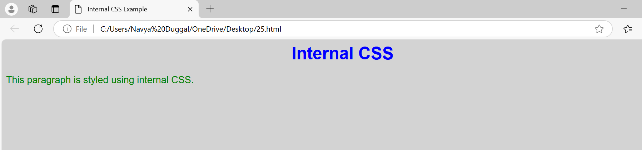

**EXERCISE-26**

Ques.)Write code to show inline CSS with HTML code.

<!DOCTYPE html>

<html>

<head>

<title>Inline CSS Example</title>

</head>

<body>

<h1 style="color: coral; text-align: center;">This is a heading</h1>

<p style="color: red; font-size: 26px;">This is a paragraph with inline CSS.</p>

</body>

</html>

OUTPUT:-

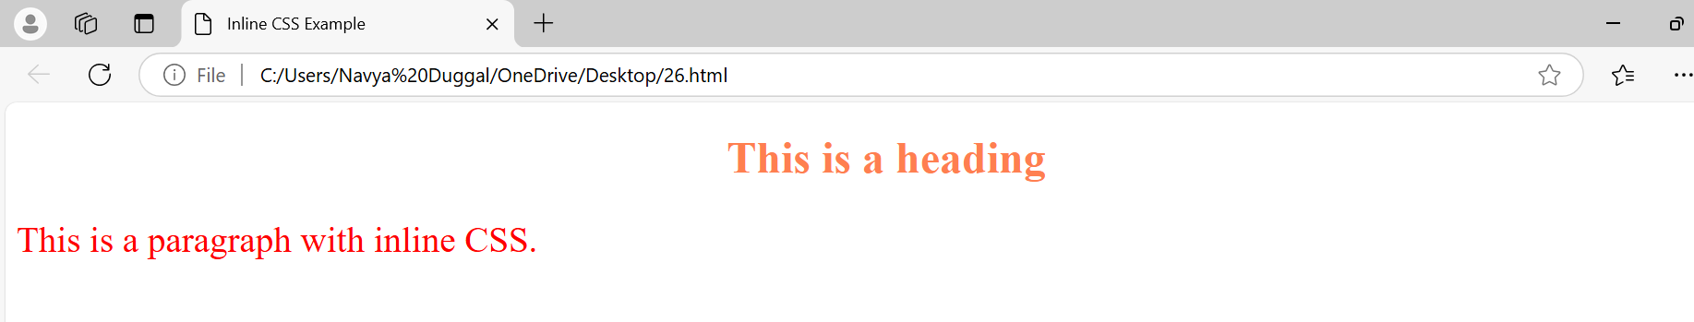

**EXERCISE-27**

Ques.)Write a program to add two numbers using form in javascript.

<!DOCTYPE html>

<html>

<head>

<title>Add Two Numbers</title>

<script>

function addNumbers() {

let num1 = parseFloat(document.getElementById("num1").value);

let num2 = parseFloat(document.getElementById("num2").value);

let sum = num1 + num2;

document.getElementById("result").textContent = "Sum: " + sum;

}

</script>

</head>

<body>

<form>

<label>Number 1: </label>

<input type="number" id="num1"><br><br>

<label>Number 2: </label>

<input type="number" id="num2"><br><br>

<button type="button" onclick="addNumbers()">Add</button>

</form>

<p id="result"></p>

</body>

</html>

OUTPUT:-

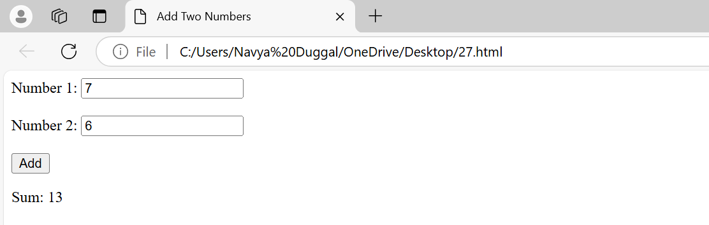

**EXERCISE-28**

Ques.)Write a program in javascript to swap two images using OnMouseOver event.

<!DOCTYPE html>

<html lang="en">

<head>

<meta charset="UTF-8">

<meta name="viewport" content="width=device-width, initial-scale=1.0">

<title>Swap Images on MouseOver</title>

<style>

img {

width: 200px;

height: 200px;

cursor: pointer;

margin: 10px;

}

</style>

</head>

<body>

<h2>Swap Images on MouseOver</h2>

<img id="image1" src="http://upload.wikimedia.org/wikipedia/commons/4/47/American_Eskimo_Dog.jpg" alt="Image 1" onmouseover="swapImages()" onmouseout="restoreImages()">

<img id="image2" src="https://tse1.mm.bing.net/th?id=OIP.t2djmrKnOvgnML3XkWpA7wHaFj&pid=Api&P=0&h=180" alt="Image 2">

<script>

function swapImages() {

const img1 = document.getElementById('image1');

const img2 = document.getElementById('image2');

// Swap image sources

const tempSrc = img1.src;

img1.src = img2.src;

img2.src = tempSrc;

}

function restoreImages() {

swapImages(); // Swapping again restores the original order

}

</script>

</body>

</html>

OUTPUT:-

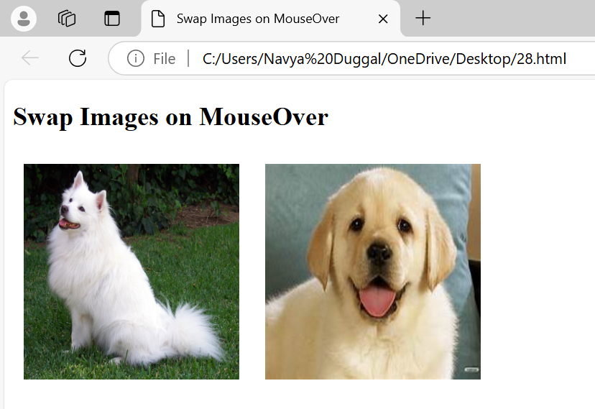

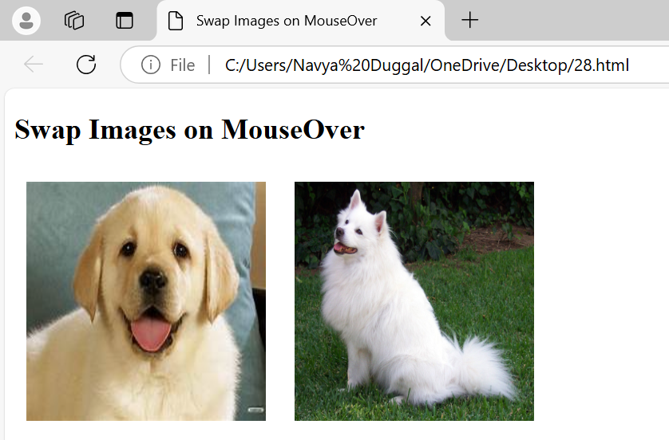

**EXERCISE-29**

Ques.)Write a javascript program to sort an array.

<!DOCTYPE html>

<html>

<head>

<title>Sort an Array</title>

<script>

function sortArray() {

// Example array

let array = [34, 7, 23, 32, 5, 62];

// Sort the array in ascending order

array.sort((a, b) => a - b);

// Display the sorted array

document.getElementById("result").textContent = "Sorted Array: " + array.join(", ");

}

</script>

</head>

<body>

<h1>Array Sorting Example</h1>

<p>Click the button below to sort the array:</p>

<button onclick="sortArray()">Sort Array</button>

<p id="result"></p>

</body>

</html>

OUTPUT:-

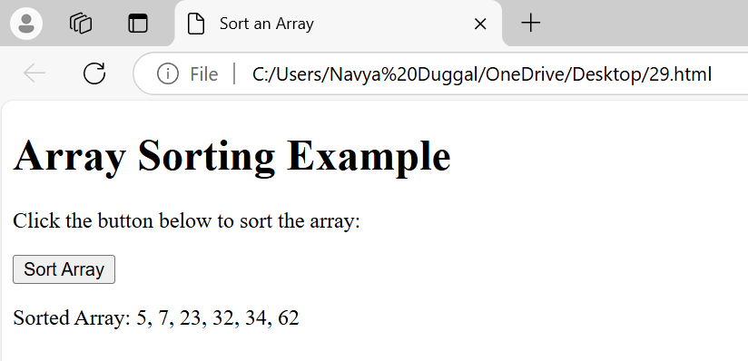

**EXERCISE-30**

Ques.)Write a javascript program to take as input three numbers from the user. Find the minimum and maximum of the three numbers. Print the following in BOLD in the following format.

<!DOCTYPE html>

<html>

<head>

<title>Find Minimum and Maximum</title>

<script>

function findMinMax() {

// Take three numbers as input from the user

let num1 = parseFloat(prompt("Enter the first number:"));

let num2 = parseFloat(prompt("Enter the second number:"));

let num3 = parseFloat(prompt("Enter the third number:"));

// Validate input

if (isNaN(num1) || isNaN(num2) || isNaN(num3)) {

alert("Please enter valid numbers.");

return;

}

// Calculate minimum and maximum

let min = Math.min(num1, num2, num3);

let max = Math.max(num1, num2, num3);

// Display the results in bold format

document.getElementById("result").innerHTML = `

<b>MINIMUM = ${min}</b><br>

<b>MAXIMUM = ${max}</b>

`;

}

</script>

</head>

<body>

<h1>Find Minimum and Maximum</h1>

<button onclick="findMinMax()">Find Min and Max</button>

<div id="result"></div>

</body>

</html>

OUTPUT:-

